# American International University- Bangladesh (AIUB) Faculty of Engineering (EEE)

**Course Project Report Outline (Microprocessor and Embedded Systems)**

## Download the template for report writing from the link:

***https://drive.google.com/drive/folders/1t_lXp8aZKScgeYL_iBoguYQr64c9xfg?usp=share_link***

## Abstract (at least 150 words but not more than 300 words) and Keywords (3-6 keywords separated by a comma) [2 mark]

1. **Introduction**

|  |  |
| --- | --- |
| 3.1. Background of Study and Motivation | [2 mark] |
| 3.2. Project Objectives | [1 mark] |
| 3.3. A brief outline of the report | [1 mark] |

1. **Literature Review *(At least 5 project-related published journal papers within the year 2018 to 2022)*** → [**Part under OBE assessment]** [5 mark]

## Methodology and Modeling

|  |  |  |
| --- | --- | --- |
| 5.1. Introduction mark] |  | [1 |
| 5.2. Working principle of the proposed mark] | project | [1 |
| 5.2.1. Process of Work | [2 mark] | |
| 5.3. Description of the components | [1 mark] | |
| 5.4. Implementation mark] | [2 | |
| 5.5. Test/Experimental setup | [2 mark] | |

1. **Cost analysis** [1 mark]

## Results and Discussion

|  |  |
| --- | --- |
| 7.1. Simulation/Numerical analysis | [2 mark] |
| 7.2. Measured response/Experimental results | [2 mark] |
| 7.3. Comparison between numerical and experimental results | [2 mark] |
| 7.4. Limitations in the project | [1 mark] |

1. **Conclusion and future endeavors [2 mark]**

## References [1 mark]

1. **Appendix (if any)**

Project Report on Smart Home Appliance controller

# American International University- Bangladesh (AIUB) Faculty of Engineering (EEE)

|  |  |  |  |
| --- | --- | --- | --- |
| **Course Name:** | Microprocessor and Embedded Systems | **Course Code:** | EEE 4103 |
| **Semester:** | Fall 2022-2023 | **Section:** | H |
| **Faculty Name:** | TAHSEEN ASMA MEEM | | |

|  |  |
| --- | --- |
| **Capstone Project Title:** | Arduino Based Smart Home System |
| **Project Group No.** | 07 |

|  |  |  |
| --- | --- | --- |
|  | **Student ID:** | **Student Name:** |
| **1.** | **Moinul Islam** | 20-42390-1 |
| **2.** | ANTOR, MD. SHAHRIAR | 18-37394-1 |
| **3.** | SOURAV, DEBANGSHU PAL | 18-37413-1 |
| **4.** | Md Tanvir Alam Niloy | 19-39422-1 |
| **5.** | Ali Rafsan Kabir | 19-40625-1 |
| **6.** | Tamalika Bhowmick | 19-41120-2 |

## Assessment Materials and Marks Allocation:

|  |  |  |  |
| --- | --- | --- | --- |
| **Cos** | **Assessment Materials** | **POIs** | **Ma rks** |
| CO 3 | Course Project report ***(Demonstrate a course project using microcontrollers, sensors, actuators, switches, display devices, etc. that can solve a complex engineering problem in the electrical and electronic engineering discipline through appropriate research)*** | **P.d.1.P3** | **5** |

|  |  |  |  |  |  |  |
| --- | --- | --- | --- | --- | --- | --- |
| **CO** | Excellent to proficient  [5- 4] | Good [3] | Acceptable [2] | Unacceptable [1] | No respo nse  [0] | Secu red mar ks |
| **CO3**  **P.d.1. P3** | The outcome of the project demonstrates a course project using microcontrolle rs, sensors, actuators, switches, display devices, etc. that can solve a complex engineering problem in the electrical and electronic engineering discipline through appropriate research. | The outcome of the project somewhat demonstrates a course project using microcontrolle rs, sensors, actuators, switches, display devices, etc., and also somewhat solves a complex engineering problem in the electrical and electronic engineering discipline through appropriate research. | The outcome of the project demonstrates a course project using microcontrolle rs, sensors, actuators, switches, display devices, etc. but cannot solve a complex engineering problem in the electrical and electronic engineering discipline through appropriate research. | The outcome of the project does not demonstrate a course project using microcontrollers  , sensors, actuators, switches, display devices, etc. also cannot solve a complex engineering problem in the electrical and electronic engineering discipline through appropriate research. | No Respo nse |  |
| **Com ments** |  |  |  |  | Total marks (5) |  |

**Smart Home System**

***Abstract*— Due to its cheaper cost and simplicity of use, home automation has become wildly popular in recent years. Having the financial ability to manage certain elements of our homes. Having the capacity to act automatically in response to conditions is useful. They are growing in importance and popularity due to security issues. In this work, a smart monitoring and controlling system for real-time control of home electrical appliances are designed and prototyped. Moreover, it stops the unnecessary loss of electrical energy caused by home appliances. This idea will make use of sensors, running clocks, and other devices to operate electrical machinery. It increases energy without sacrificing the clients' comfort. Another available option is the remote control. The framework primarily inspects the electrical limits of household appliances like voltage and current and so determines the amount of power consumed. The exciting feature of this framework is how the apparatuses may be controlled in lots of ways while using minimal amounts of resources. As a result, consumers can save money. Additionally, if necessary, the framework can be physically controlled. The system has the capacity to monitor and manage home items including fans, lighting, and temperature.**

**Keywords— Energy consumption; home automation; Arduino, Controlling, and Monitoring Device**

* 1. **INTRODUCTION**
  2. Background of Study and Motivation

A home automation system is designed to automate the control of household electronics whether the user is at home or away. The capacity to automate functions around the home is provided by home automation. A home appliance is a tool or gadget created specifically for a domestic setting, most often an electrical appliance like a refrigerator. Although they are not always accepted due to their complexity and cost, home automation systems are quickly gaining acceptance worldwide, with end users including the elderly and disabled. Population aging is a global phenomenon that affects almost every nation. Age is caused by a decrease in mortality and, more critically, a decrease in fertility. This process results in a decrease in the proportion of children in the population and an increase in the proportion of adults in the major working ages and older people. [1]

A smart home is a networked collaboration of technology and services for better living. A smart home is one that has been automated, making daily duties simple and convenient. All electronic devices can now reply intelligently thanks to this technology. A smart house simulation model is made using Proteus simulation. This smart house model will make

it easier for physically challenged people to control their home appliances like lights, lamps, fans, and many more items The simulation technique employed in our project is called Proteus simulation. Our study also shows how to create a smart house model using the Proteus simulator. In order to create an embedded system that can do simple, targeted, and repetitive tasks without requiring human input, the design and implementation of an embedded system for the smart home using Proteus require a strong interdependence of both hardware and software. Our smart home concept is entirely sensor-based using a Proteus simulator and sensors.

* 1. Project Objectives

In this study, we produced a smart home automation system that can be operated remotely to monitor and regulate the temperature, humidity level, room temperature, alarms, and other household appliances. Using motion and light sensors both inside and outside the house, this system can also regulate the lighting.

* 1. A brief outline of the report

In this report, we have done our project Arduino-based smart home system by software and hardware which is called an embedded system. Here are 2 motor fans and 2 LED lights we have used in our project. One temperature sensor, one sonar sensor, and one LDR, two resistors, two relays, some wires are also in our project. One LED light will switch on if any object inside 15c.m to the sonar sensor. Another one will be switched on if the LDR is fully dark which means the room is fully dark the light will automatically on. If the room is dark, the lights will come on automatically. When the room is light, the lights will automatically switch off. And among our two motor fans, one fan will be on if the room temperature is between 22 degrees Celcius to 25 Celcius. And Both fans will be on if the temperature is upper than 25 degrees Celcius. If the room temperature is below 22 degrees celsius then no motor fan will run. And this will work like this.

* 1. **LITERATURE REVIEW**

A smart home network that enables information to be transferred between things, together with a residential gateway that connects the smart home to the outside Internet world, are all components of a smart home. [2] It is possible to interact with or see smart items residents.

Simple examples of these smart products include lights that we can turn on or off, refrigerators that know when food is running low and can order more on their own, cellphones, security systems, on-demand media, and so on. [3] All of these devices will be wired into the household network in order to send and receive orders or to communicate their conditions. The home can be completely connected and controlled both internally and externally thanks to home networking. [4] Through Ethernet or the Internet, the residential gateway offers external communication. [5] This gateway enables the home to both download and connects to new services. The service provider is accountable for providing residents with new services and ensuring their accessibility. [6]

* 1. **METHODOLOGY & MODELING**
  2. Working principle of the proposed project
     1. Process of work
* Smart Home Appliance controller is a home automation system based on the Arduino Uno microcontroller, with three separate sensors, this project has specified three major functionalities.
* Luminosity of the Grove The room's darkness is detected by the sensor. If the room is dark, the lights will come on automatically. When the room is light, the lights will automatically switch off.
* The grove Temperature Sensor takes the temperature reading. The fan's speed is controlled by the temperature reading. Fans vary their rotation speed according to the temperature.
* The Grove - An ultrasonic ranger measures the distance between objects or particles in the room. The Arduino LED will automatically switch on if the ranger senses any echo.
* Grove - LED is intended for Arduino novices who want to monitor digital port controls. It can easily be attached to the surface of your box or desk and used as a power or signal pilot

lamp. A potentiometer can be used to alter the brightness.

* 1. Description of the Components

For simulation, we used sensors, an Arduino Uno, and LED in Proteus 8.9 professional.

There are three types of sensors used in this project, here grove temperature sensors, grove ultrasonic ranger, and grove luminance sensors to measure room temperature, obstacle distance, and light density. The Grove temperature sensor is connected pin A1, and a variable called Temp C has been created to store the sensor's output value.

* 1. Implementation

If it is greater than the maximum speed then the motor will be taken through pin 3. If it is between 22 and 25, the fan speed will be in the middle range, and if it is less than 22, the value of the analog write will be zero, indicating that the motor will not rotate. To control the light in the room, a luminance sensor has been employed, which is attached to pin A0. And a variable called lux has been used to hold the light density, which is used to turn on and off the light. A groove red LED has been used as a light source and is attached to D2. The lead will be turned on when the value is less than 300.

To automate room appliances based on the arrival of objects in the room. The circuit can be turned on to measure an object's appearance distance from the room. The Grove ultrasonic ranger is used to measure the distance between objects, and the LED is turned on as a result of this. The Arduino LED is attached to pin 11 and the sensor is connected to D7. The read Centi- meters function converts the sensor reading into a variable named cm. The yellow light will turn on whenever the value is less than or equal to 15.

* 1. Test/Experimental setup

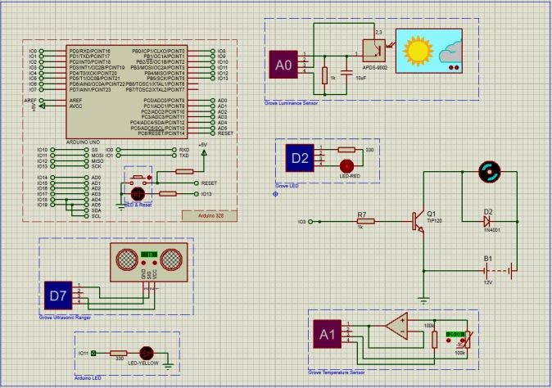

***Figure: A schematic view of a smart home***

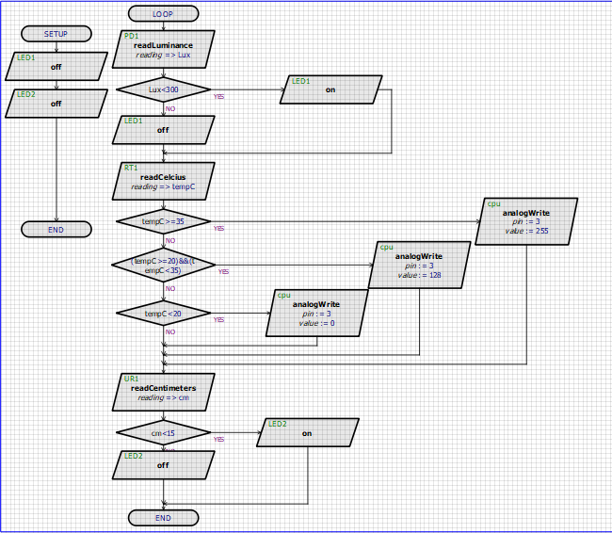

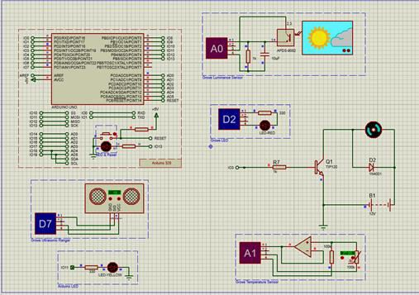

***Figure: Flowchart of our project***

* 1. **RESULT AND DISCUSSION**

In this section, all the snapshots during the runtime simulation in proteus are attached and the hardware project picture is attached.

4.1. Simulation/Numerical analysis

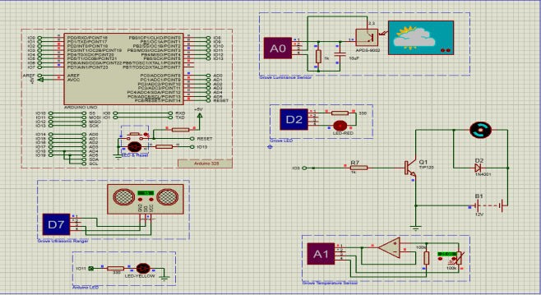

***Figure 1: Grove LED is on because the room is dark***

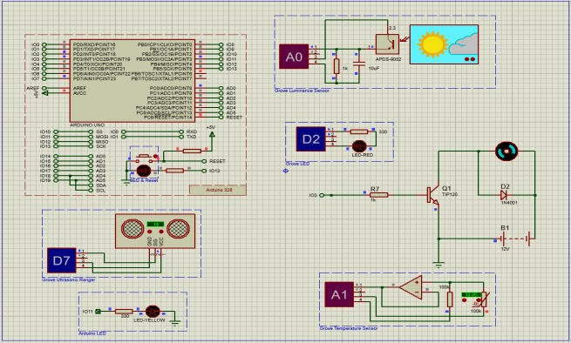

***Figure 2: Motor is off because the temperature is less than 22 degrees.***

**Figure 3: Motor is off because the temperature is more than 25 degrees.**

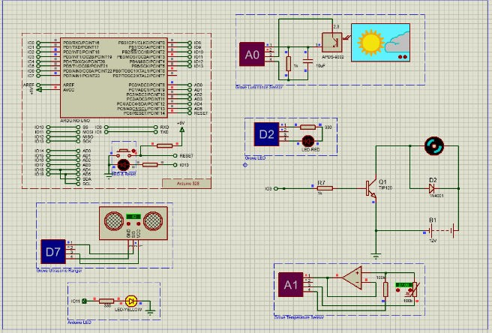

***Figure 4: Arduino yellow LED is on because the object is 12 cm which is less than 15 cm.***

4.2. Measured response/Experimental results

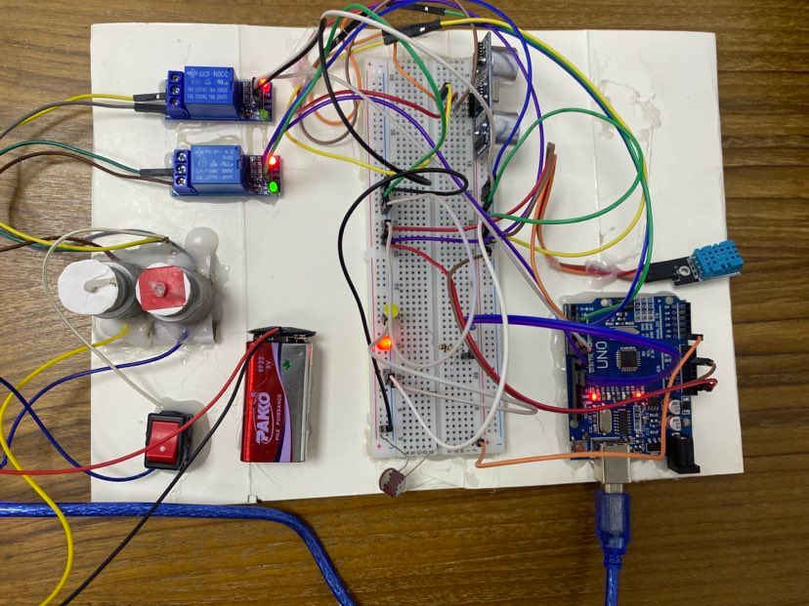

***Figure 5: Hardware picture of smart home systems***

4.3. Comparison between numerical and experimental results

Figures 1 show that when the room becomes darker, the room light (grove LED) automatically turns on, and when the room becomes bright, the room light (grove LED) automatically turns off. At the same time, we can see in figures 2 and 3 that the motor is off when the temperature is low (less than 22 degrees), the motor speed is intermediate when the temperature is medium (between 22 and 25 degrees), and the motor speed is maximum when the temperature is high (more than 25 degrees). Furthermore, as shown in figure 4, if any objects (humans) approach the room (within 15 cm), the room light (Arduino yellow LED) turns on automatically, however, if the item (human) approaches the room (further than 15 cm), the room light (Arduino yellow LED) remains off.

4.4. Limitation in the project

The ultrasonic ranger sensor does not know how to distinguish between the right and wrong person which could trigger a redundant electricity supply. Everyone has different preferences for fan speed at different temperatures which can lead to a problem because the fan speed settings cannot be changed by the consumer. Sometimes people do not prefer to turn on the light at certain times which is another limitation of our project as light on/off is based on luminance sensor settings.

**V. Conclusion and future endeavors**

This project simulation displays a design and implementation concept for a Proteus-based Arduino microcontroller-based smart home automation system. The sensors are wired to the Arduino. Board with a microcontroller Any signals received from connected sources sensors can be used to automatically monitor, control, and access home appliances. Even if several problems that developed throughout the project couldn't be fixed in the allocated amount of time, our project management solution has succeeded.

**VI. References**

1. “World Population Ageing” Department of Economic and Social Affairs Population Division, United Nations, New York, 2013J. Clerk Maxwell, A Treatise on Electricity and Magnetism, 3rd ed., vol. 2. Oxford: Clarendon, 1892, pp.68–73.
2. Ma Naing, Ni Ni San Hlaing K. Elissa “Arduino Based Smart Home Automation System” pp. 276
3. Subhankar Chattoraj “Smart Home Automation based on different sensors and Arduino as the master controller’’ Volume 5, Issue 10, October 2015, pp - 736
4. International Journal of Scientific Research in Information Systems and Engineering VOLUME 2, ISSUE 2, AUGUST – 2016. ISSN 2380-8128
5. Daniel Chioran and Honoriu Valean, “Arduino based Smart Home Automation System” International Journal of Advanced Computer Science and Applications(IJACSA), 11(4), 2020. http://dx.doi.org/10.14569/IJACSA.2020.0110410
6. Pedro F. Pereira, Nuno M. M. Ramos, M. Lurdes Simões. (2020) Data-driven occupant actions prediction to achieve an intelligent building. Building Research & Information 48:5, pages 485-500.